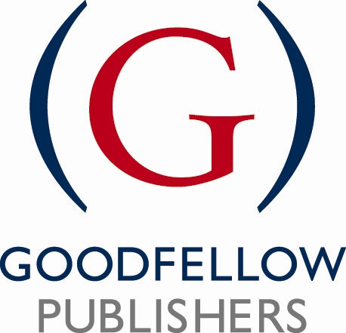

Reviewer’s Questionnaire

Title:
Reviewer's name:
Address:

Many thanks for agreeing to complete this review – your time and comments are much appreciated. Please complete the questions below including as much detail as possible.

Type into the right hand column, which will expand as you type where necessary.

Knowledge, Content and Writing Style
Is the coverage of the subject adequate and appropriate for the subject?
Does the author(s) demonstrate command of the subject?
Are there any noticeable omissions in the content or should any topics be deleted?
In general, what are the best and weakest features of the proposal?
Is the style of writing, terminology and vocabulary suitable for the intended reader?
Please comment on any individual chapters that you think are particularly strong.
Please comment on any individual chapters that you think look weak.
What do you think of the balance in the proposal between theory and its application?
Overall, can you make any other suggestions that the author could take on board to improve this material?

Pedagogical features
How do you rate the overall pedagogical approach for the material?
What do you think of pedagogical features such as Chapter Summaries Review Questions Case studies Further reading, which are proposed or needed in the material?
Are the illustrations, tables and diagrams clear, pertinent and functional?
Are there any other features that you would like to be included to suit your style of teaching?
Market & Competition
What are the leading materials (books, online material etc) in this area (if possible, please list author, title, publisher)?
Is there a need for this new material? If so, who might buy it?
What are the strengths and weaknesses of this text in relation to the competition?
What courses taught at your institution or elsewhere might this text be used for? What features would make you consider this material for adoption?
Would you envisage this being a core textbook/one of a few textbooks used / recommended reading / research reference/ academic background interest?
What price range would you consider appropriate?
Other issues
Please add any further comments.
Have you any writing plans for this or any related area?

Please email your completed review as an attachment to:

Sally North, Publisher
Goodfellow Publishers Limited
Mobile: 07748 635 789
Email: sally.north@goodfellowpublishers.com

Goodfellow Publishers Limited, 6 Nourse Close Woodeaton Oxford, OX3 9TJ Registered Company No. 06517764

